Health departments are welcome to adapt this tool. Requirements for adapting this tool include: Health Evidence™ and Peel Public Health are acknowledged for tool development; and adapted tool cannot be used for profit (not to be sold).
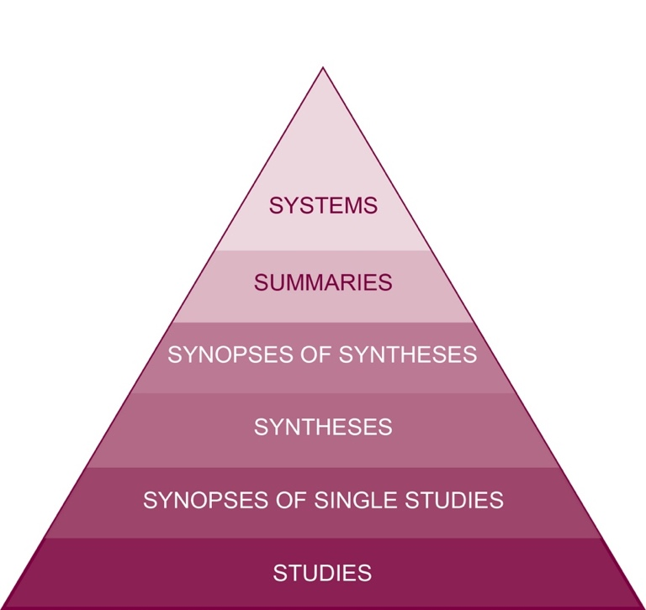

The Health Evidence™ team has reviewed the update for the evidence-based health care (EBHC) 5.0 pyramid for accessing pre-appraised evidence and guidance and concluded the 6S pyramid continues to be the most applicable version for a public health audience. The team would like to acknowledge the value of differentiating between evidence-based online texts and guidelines as in the 5.0 pyramid. These differences are noted in the ‘summaries’ section of the Health Evidence™ practice tool “Resources to Guide & Track your search”.
Haynes, R.B. (2001). Of studies, syntheses, synopses, and systems: The "4S" evolution of services for finding current best evidence. Evidence Based Medicine, 6:36-38.
Haynes, R.B. (2007) Of Studies, Synthesis, Synopses, Summaries and Systems; The 5 S's evolution of information services for evidence-based healthcare decisions. Evidence Based Nursing, 10:6-7.
DiCenso, A., Bayley, L., Haynes, R.B. (2009). Accessing pre-appraised evidence: Fine-tuning the 5S model into a 6S model. Evidence Based Nursing, 12:99-101.

Robeson, P., Dobbins, M., DeCorby, K., Tirilis, D. (2010) Facilitating access to pre-processed research evidence in public health. BMC Public Health. 10(1): 95.
Alper, B.S., Haynes, R.B. (2016). EBHC pyramid 5.0 for accessing preappraised evidence and guidance. Evidence-based medicine, 21(4): 123-125.
The National Collaborating Centre for Methods and Tools. The 6S Search Pyramid Tool. Retrieved from: http://www.nccmt.ca/capacity-development/6s-search-pyramid [January 2018].

Have you used this tool?
We would appreciate hearing from those who have used the tool, perspectives on its usefulness, how it was adapted, and any suggestions for revision:
info@healthevidence.org.
How to cite tool: Health Evidence™ (2009, November 25). Levels & Sources of Public Health Evidence. Retrieved [insert date you downloaded this document e.g., January 13, 2018], https://healthevidence.org/practice-tools.aspx#PT3

* Health Evidence is grateful to Peel Public Health, Communicable Disease Division, for co-developing and field-testing the November 2009 version of this document.

